2015-ZA-01-EN.odt COMPASS ROSE
0 ---- | I: ---- | II: ---- | III: ---- | IV: ----

Answer Type: Click to choose! Mandatory for: none

Body

On the map below, the numbers represent towns. A compass rose is provided to indicate North, South, East and West.
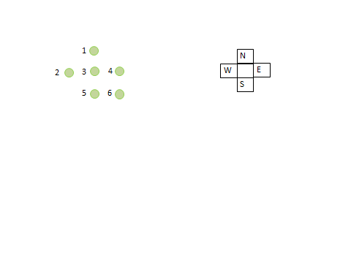
The names of the towns are A, B, C, D, E and F.
We have the following information:
C is south of A and south-east of D.
B is south-west of F and north-west of E.
D is south of F.

Question

Which town is at position 6?

Answer

Correct answer is C

Explanation

Explain which is the correct answer and why. This must understandable for the target age group. Use about 2 to 5 sentences. Focus narrowly on the task, do not explain yet what this has to do with informatics.

It's informatics

Sometimes a problem takes logical step by step reasoning and repeated testing to find a solution. This particular problem requires a step by step placing of the towns with each step being tested before the next is implemented.

Keywords

Abstraction, reasoning, testing, solution

Websites

Indicate websites (in English and other languages) which offer further information on the particular domain of informatics mentioned in the “It's informatics” part. Wikipedia is often a good start.

Internal Use

Wording

List of word used to name important things in the task body (concepts, definitions, objects, names, etc.) This is to ensure the consequent use of terms in the task body and facilitates translation.

Comments

Author, e-mail, Date (YYYY-MM-DD), Comment.

Graphics

Please indicate:
- Source of the all used images to produce the task image(s): (Url and/or author)
- Licence of all the individual images

Note: If it is not clear where the images are from, they might be copyrighted and cannot be used in the task.

Files

All additional files for this task (graphics, scripts, etc.)
2015-ZA-01-EN.odt (this file)

Authorship

List all authors who have contributed to this Document, with e-mail and country.

License

Copyright © 2014 Bebras – International Contest on Informatics and Computer Fluency. This work is licensed under a Creative Commons Attribution-NonCommercial-ShareAlike 3.0 Unported License (CC BY-NC-SA 3.0). Visit: http://creativecommons.org/licenses/by-sa-sa/3.0/

